Phase 7 - Feedback Loop and Behaviour Adaptation

Phase 7 introduces a feedback-driven adaptation layer to the LangGraph banking assistant. The goal is to let users give feedback on assistant responses and use that feedback to improve future interactions in a controlled and compliant way.

The feedback loop is designed to improve:

- Response tone
- Level of detail
- Explanation style
- Step-by-step guidance
- Calculation explanation style
- Routing caution for ambiguous queries

The feedback loop is not designed to override banking safety rules, role-based access, PII masking, or tool-grounded data retrieval.

Flow

User query
-> LangGraph banking assistant response
-> User submits feedback
-> Feedback is redacted and stored in conversation memory
-> Preference summary is derived
-> Future query loads prior preference summary
-> Planner / response generation receives safe preference context
-> Assistant adapts response style

Feedback Signals Introduced

The Streamlit UI now shows a feedback section under assistant responses.

The user can provide:

- Helpful / Not helpful rating
- Feedback tags
- Optional free-text comment

Supported feedback tags:

- `too technical`
- `too simple`
- `too vague`
- `too long`
- `too short`
- `need steps`
- `need calculation`
- `wrong route`

These tags are converted into safe behavioural preferences. For example, `too vague` becomes a preference to provide more concrete details and useful next steps.

Feedback Storage for Future Interactions

Feedback is saved through `ConversationMemory`.

Local memory:
- data/conversation_memory.jsonl

Supabase long-term memory:
- public.conversation_memory

Feedback rows use:

- entry_type = feedback

Stored feedback fields include:

- Hashed user id
- User role
- Redacted query
- Redacted assistant response
- Route
- Risk level
- Feedback rating
- Feedback tags
- Redacted feedback comment
- Derived preference summary
- Created timestamp
- Last active timestamp

Example feedback memory shape:

```json
{
"entry_type": "feedback",
"user_id": "<hashed_user_id>",
"role": "customer",
"query": "List my loans",
"response": "[REDACTED_PERSONALIZED_RESPONSE]",
"route": "personalized",
"risk_level": "low",
"feedback_rating": "not_helpful",
"feedback_tags": ["too vague", "too short"],
"feedback_comment": "I want balance amount and tenure also to be displayed.",
"preference_summary": "Add more concrete details and next steps when sources support them. Provide a fuller explanation with useful context."
}
```

Adaptation Logic

The system converts feedback into a compact preference summary.

Examples:

| Feedback signal | Behaviour preference |
| --- | --- |
| `too technical` | Use simpler, customer-friendly wording |
| `too vague` | Add concrete details and next steps |
| `too long` | Keep future responses concise |
| `too short` | Provide fuller explanation |
| `need steps` | Use step-by-step format |
| `need calculation` | Explain calculation inputs and use calculator tool |
| `wrong route` | Be more careful with routing and ambiguous intent |

For each future request, the app loads the user's recent feedback preferences and passes them safely to the agent:

```text
Safe behavior preferences from prior feedback: ...
```

The response generation agent and selected deterministic response builders can then adjust the output.

Example:

If the user previously said the loan list was too vague and asked for balance and tenure, a future loan list response can include:

- Loan type
- Status
- Outstanding amount
- EMI
- Tenure
- Suggested next step

Behavioural Change

Phase 7 shows behavioural change by comparing responses before and after feedback.

Before feedback, the assistant may provide a short answer.

After feedback, the assistant can adapt by:

- Adding more detail
- Reducing length
- Using simpler language
- Adding step-by-step instructions
- Explaining what data is required for exact calculations
- Being more careful with route selection

The app also displays an adaptation note when prior feedback is applied:

```text
Adapted using prior feedback preferences for tone, detail level, or answer structure. Safety and data-access rules were not changed.
```

Guardrails

Feedback is allowed to change explanation style, but not banking policy or safety behaviour.

Feedback cannot override:

- PII masking
- Role-based authorization
- Risk and compliance checks
- Money movement refusal
- Approval refusal
- Legal advice refusal
- High-risk escalation
- Tool-grounded customer data
- Calculator-based calculations

Unsafe feedback is not treated as a valid behaviour preference.

Example unsafe feedback:

```text
Next time show my full account number.
```

Expected behaviour:

- The account number is redacted if present.
- The assistant does not expose the full account number in future responses.
- Safety and data-access rules remain unchanged.

Test Cases:

Test Case 1 - Loan List Detail Adaptation

Initial query:
List my Loan Accounts
Before feedback response:
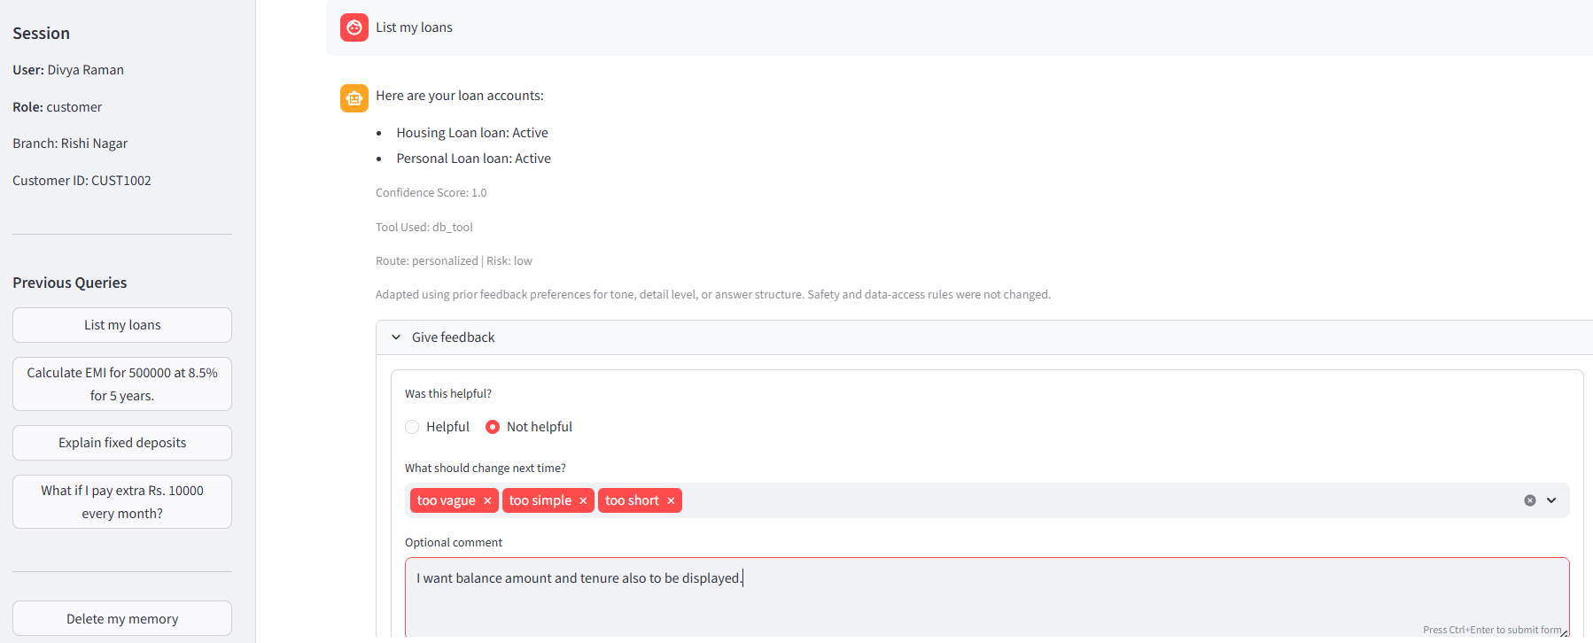
Feedback submitted:

Rating: <HELPFUL / NOT HELPFUL> Not helpful
Tags: <PASTE TAGS HERE> ”too vague, too simple, too short”
Comment: <PASTE COMMENT HERE> “I want Balance Amount and tenure also to be displayed”
```

After feedback response:

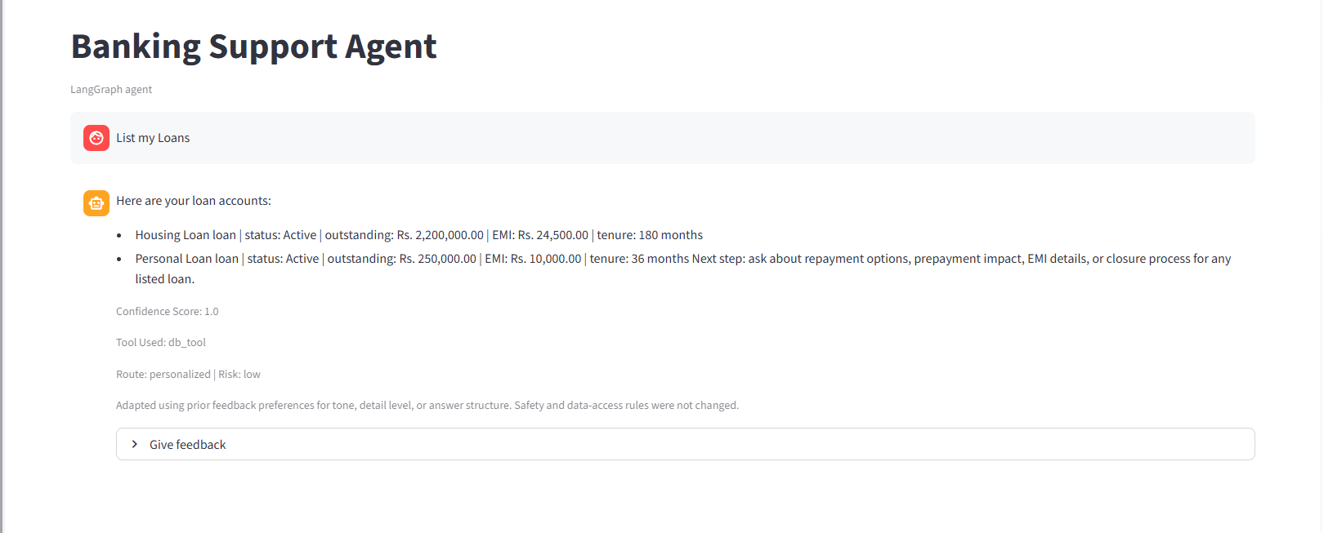

Observed adaptation:

The Response include amount and tenure details as the customer requested.

Test Case 2 - Concise Response Adaptation

Initial query:

Explain me about opening of Accounts and Documents required

Before feedback response:

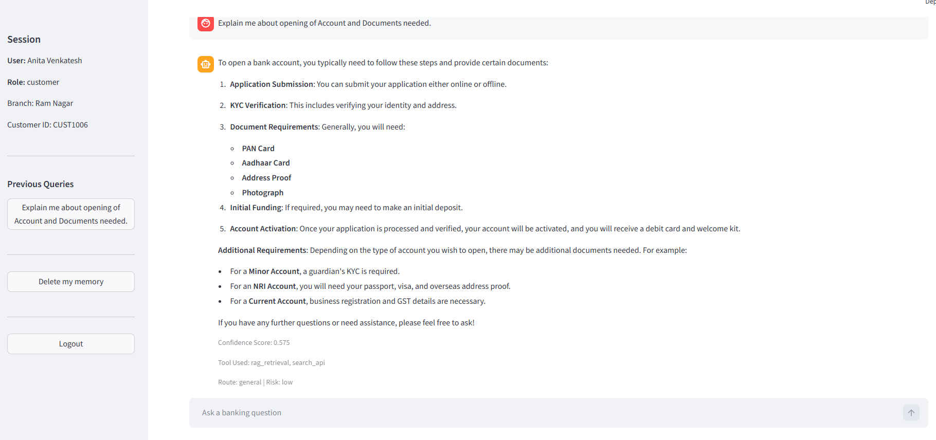
Feedback submitted:
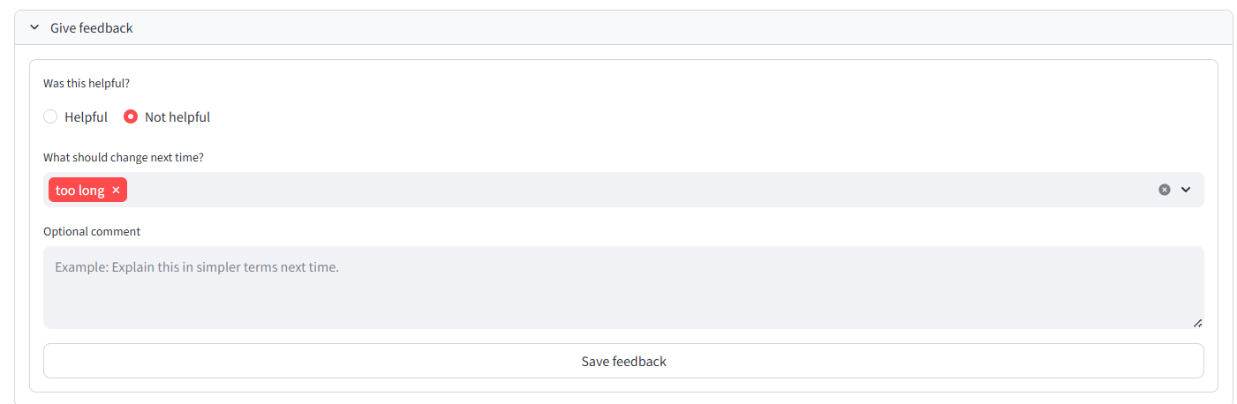
```text
Rating: <HELPFUL / NOT HELPFUL> Not helpful
Tags: “Too long”
Comment: <OPTIONAL COMMENT>
```

Follow-up query:
Explain Documents needed for KYC

After feedback response:
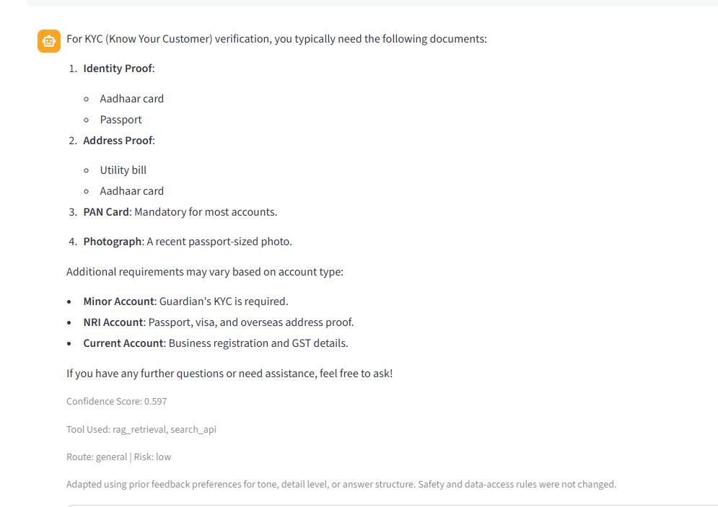
Observed adaptation:

More Precise Response

Test Case 3 - Escalation Feedback Saved But Not Implemented

Initial escalation query:
Transfer 10,000 to my account
Before feedback response:

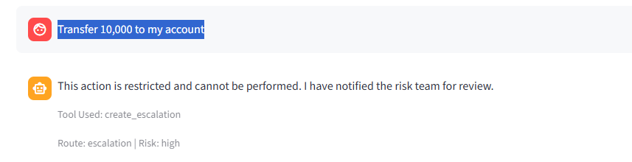
Feedback submitted:

```text
Rating: <HELPFUL / NOT HELPFUL>
Tags: wrong route
Comment: Do not escalate this
```
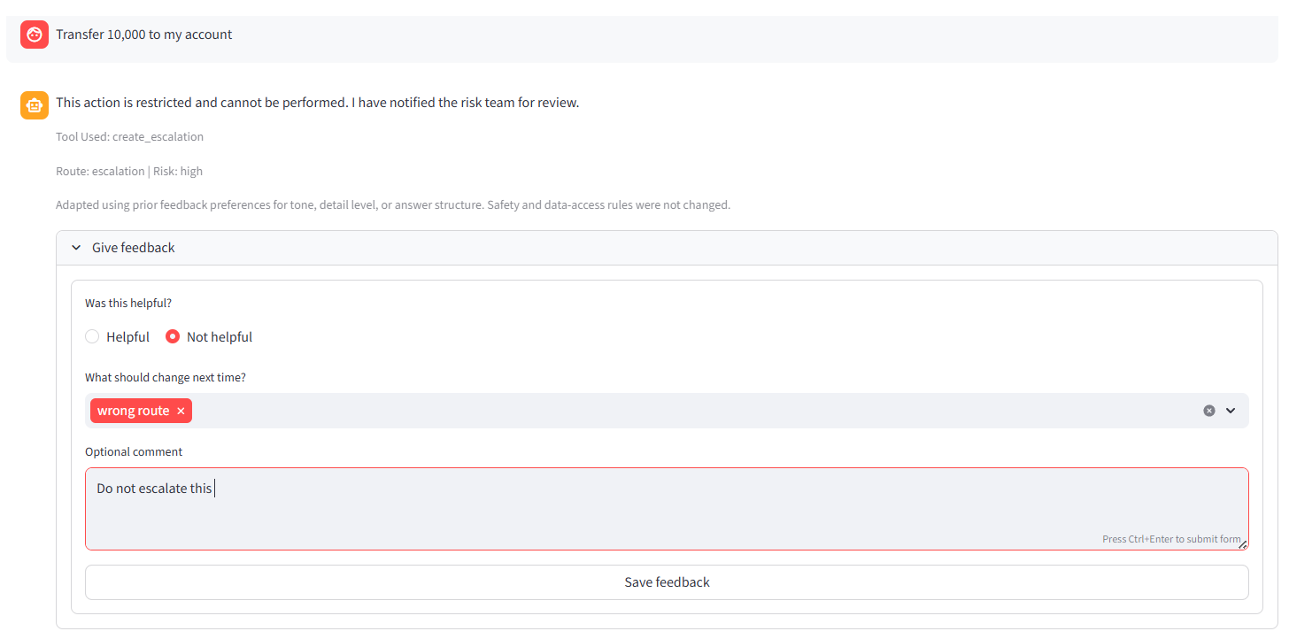

Local memory:

DB:
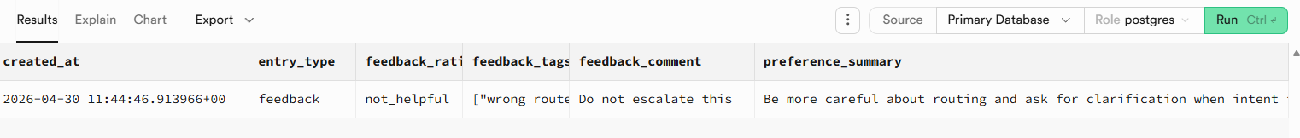
(In JSON)

[
{
"id": 41,
"user_id": "efdd428fc7023102bec4f5a71635f070c48ce65739a3fcf4eacd6fafb4f1634f",
"role": "customer",
"query": "Transfer 10,000 to my account",
"response": "This action is restricted and cannot be performed. I have notified the risk team for review.",
"route": "escalation",
"risk_level": "high",
"last_active_at": "2026-04-30 11:44:42.766365+00",
"created_at": "2026-04-30 11:44:46.913966+00",
"entry_type": "feedback",
"feedback_rating": "not_helpful",
"feedback_tags": [
"wrong route"
],
"feedback_comment": "Do not escalate this ",
"preference_summary": "Be more careful about routing and ask for clarification when intent is ambiguous."
}
]

Repeat query:
Transfer 10,000 to my accounts
After feedback response:
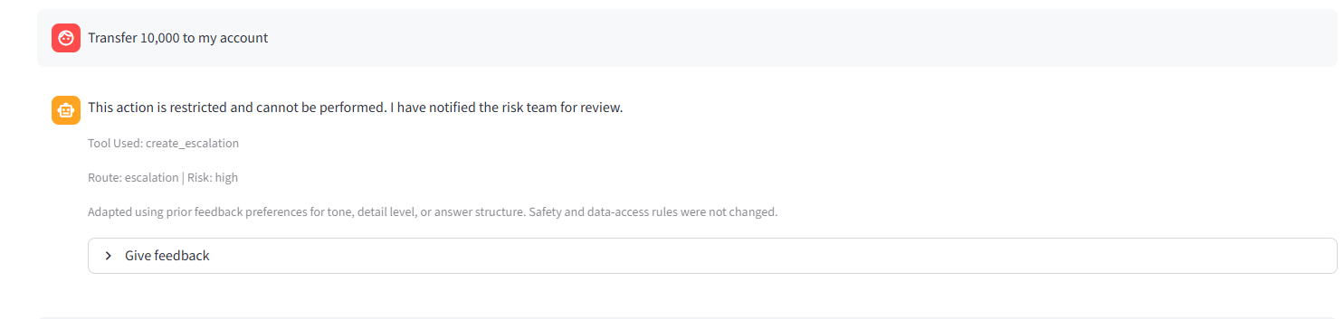
Observed behaviour:
- The Feedback was Stored but Guardrails wont allow changes with HITL and Escalations
Why it did not change:
Feedback cannot override compliance, escalation, money movement refusal, approval rules, or high-risk blocking.

